LAB REPORT
Objectives Achieved
- Learned to implement functions in C
- Practiced modular programming using separate functions
- Understood use of math library (math.h)
- Learned about data types like int and double
- Applied loops and conditional statements in problem solving
Task 1: Prime Number Generator
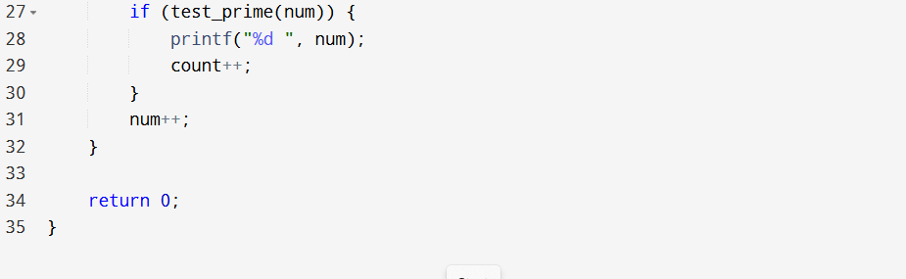
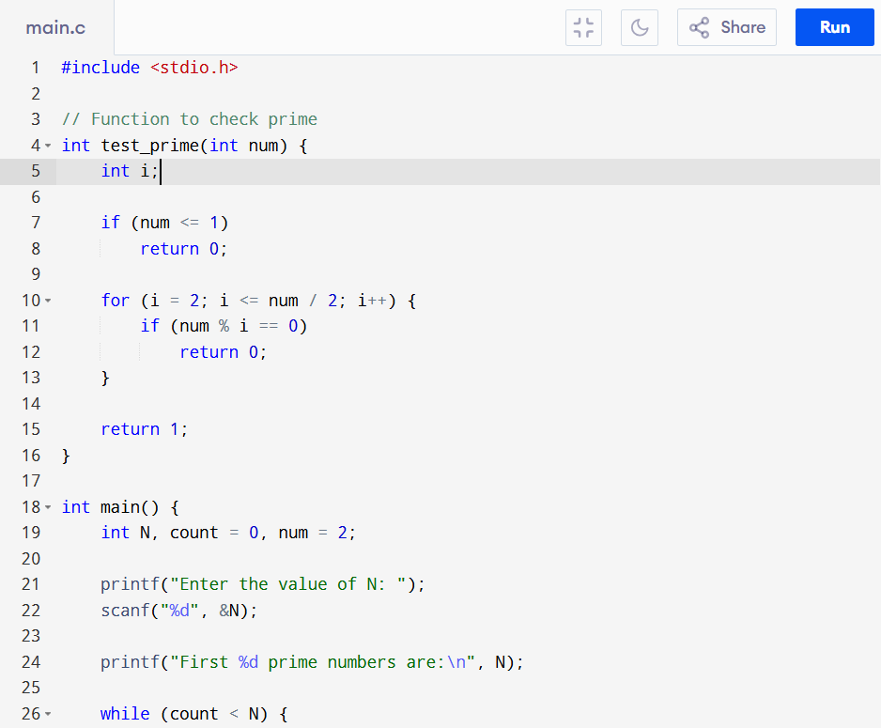
Program Code
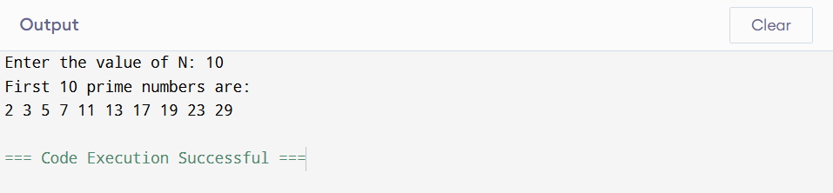
Conclusion of Task 1
In this task, we implemented a function to check whether a number is prime or not. We used loops and conditional statements to determine divisibility. The program demonstrated how functions can be reused to simplify complex problems. It also improved our understanding of iteration and logical conditions in C programming.
Task 2: Trigonometric Function Calculator
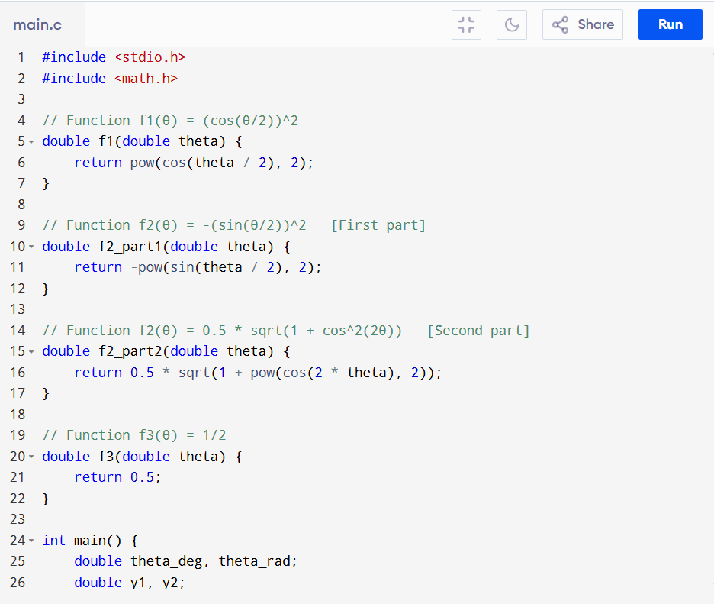
Program Code
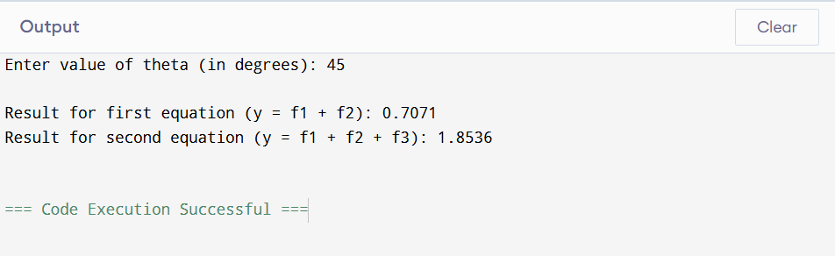
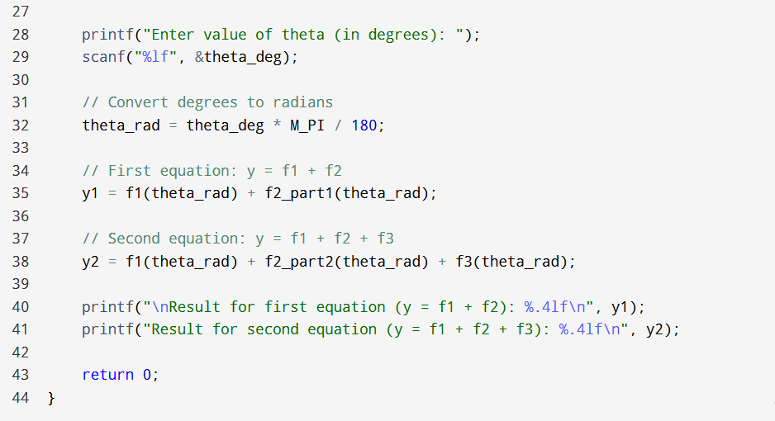
Conclusion of Task 2
This task focused on implementing mathematical functions using the C programming language. We used the math library to perform trigonometric and square root operations. The program highlighted the importance of converting degrees into radians before using trigonometric functions. It also demonstrated modular programming by dividing the problem into smaller functions like f1, f2, and f3.

Post-Lab Task
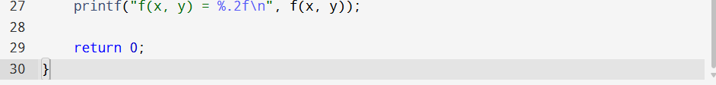
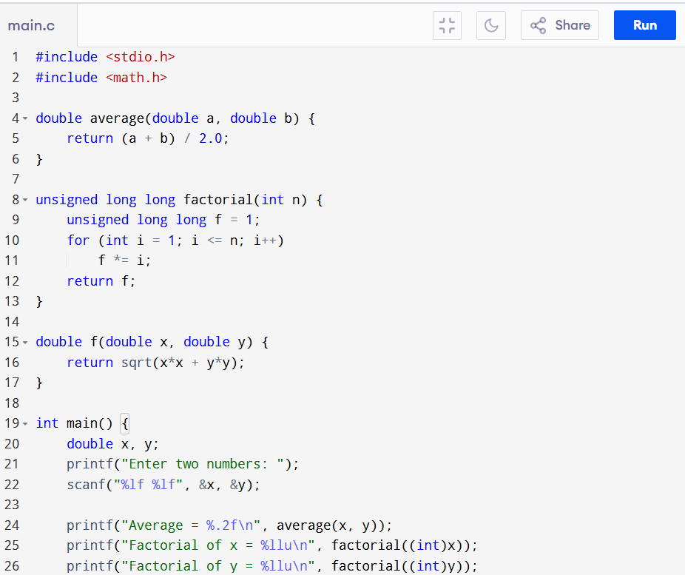
Program Code
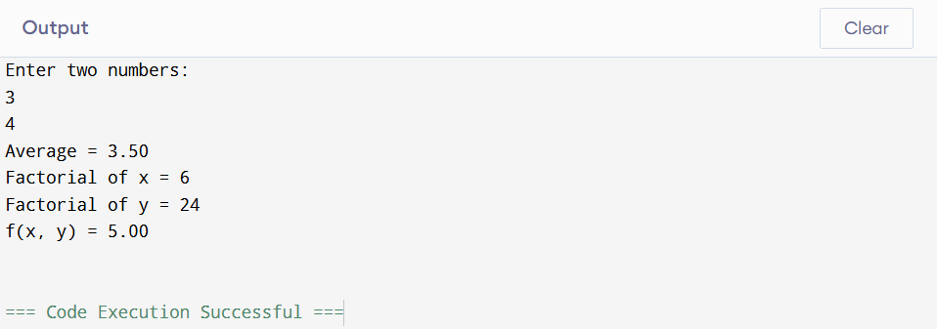
Conclusion of Post lab
In this lab task, we implemented a C program that uses separate functions to compute the average of two numbers, the factorial of each number, and the mathematical function $f(x,y)=\sqrt{x^{2}+y^{2}}$. By dividing the program into small functions, the code became easier to understand, reuse, and maintain. The program successfully took user input, performed the required calculations, and displayed the results in the main function, demonstrating the importance of modular programming in C.
Critical Analysis
This lab provided practical experience in using functions, loops, and mathematical operations in C programming. The combination of logical (prime numbers) and mathematical (trigonometric functions) problems made the lab comprehensive. Key Observations:
- Functions improve code reusability and readability
- Mathematical problems require careful handling of data types (double)
- Conversion between degrees and radians is essential
- Loops and conditions are fundamental in solving logical problems
Challenges Faced:
- Understanding prime number logic for large inputs
- Correct usage of math.h functions
- Remembering to convert degrees into radians
- Managing multiple functions and their outputs

